**CHAPTER ONE**

**1.0 INTRODUCTION**

A database is an organized collection of data. The data are typically organized to model relevant aspects of reality in a way that supports processes requiring this information. For example, modeling the availability of rooms in hotels in a way that supports finding a hotel with vacancies.

Database Management Systems (DBMS) are specially designed software applications that interact with the user, other applications, and the database itself to capture and analyze data. A general-purpose DBMS is a software system designed to allow the definition, creation, querying, update, and administration of databases. Well-known database management Software includes MySQL, MariaDB, PostgreSQL, SQLite, Microsoft SQL Server, Oracle, SAP HANA, dBASE, FoxPro, IBM DB2, LibreOffice Base and FileMaker Pro. A database is not generally portable across different database management system, but different database management can interoperate by using standards such as SQL and ODBC or JDBC to allow a single application to work with more than one database. (Bachman, 1973).

There is a need to improve the mode of doing things in the government of a nation through the organization of a standard error free and fully monitored database so that the keeping of data in every sector and arms of the government will be easier. The mode of keeping files and folders in shelves is now getting uglier and outdated and should be replaced by the modern system which will involve only few computers and its operators and can handle almost everything in the state, with less effort and complete accuracy. (Chapple, 2005).

The issue of medical care is planned centrally by every government, and is aimed at every rightful citizen; most especially the old aged people who need constant care and medical treatment. (Chapple, 2005).

The study of computer use by older people is currently booming, as this group has significantly increased its use of information and communication technologies (ICT) in daily life, on both personal and professional levels (Tatnall, 2014). In this respect, the advantages of using new technologies to develop social relationships, leisure and entertainment opportunities, and life-long learning habits and access services and care could be considered factors for successful autonomy and aging in the life of older people.

“As the availability of electronic resources for older adults increases, the quality of the aging experience will be enhanced” (McConatha, 2002) and in order to achieve involvement and counteract resistance to using these technologies, we need to bridge the “digital gap” experienced by older users by providing interfaces and tools adapted to suit their physical and cognitive characteristics (Hawthorn, 2000).

Research is inconclusive as to the positive psychosocial effects of ICT use on senior well-being (Patsoule, 2014) and as a result, its influence on the improvement of cognitive skills such as memory and attention is considered to be very weak (Slegers, 2012). However, contrary to popular belief, older people respond positively to using computers, leading to favorable changes in their interests and confidence due to the recognition of these technologies as beneficial tools and as a result of using them in training and learning programs (Wandke, 2012). Along these same lines, the results of specific studies note that cognitive abilities alone are not enough to predict older adults' computer use but that attitude variables like computer self-efficacy and computer anxiety must also be considered (Chaffin, 2005).

* 1. **Background of the Study**

At present in Osun State, the state government operated a separate database system which does not comprise both government and nongovernmental workers. The database system is operated by different ministry in the state. For example the database of retirees is controlled by the pension scheme of the state which has nothing to do with nongovernmental senior citizen. This has been a major drawback for the state in controlling and monitoring the affairs of overall senior citizen in the state as a result of lack of centralized database system for senior citizen.

Hence, this project work was carried out to develop an ICT assisted database for senior citizens of Osun State for efficient management and use of information about senior citizens of Osun State.

**1.2 Statement of the Problem**

Investigation has revealed that there is no centralized database system operated by Osun State Government for storing, controlling and managing both government and nongovernmental senior citizens information and social welfares in the state. Information shows that ministries within the State i.e ministry of works etc operated a separate senior citizen database for their retirees which are not centralized.

Hence, in this project work, An ICT Assisted Database for Senior Citizen of Osun State, which allows proper planning of social welfare schemes for senior citizens was designed, implemented and evaluated.

**1.3 Aim and Objectives the Project**

The project is aimed at developing An ICT Assisted Database for Senior Citizen of Osun State. The specific objectives are;

1. To design An ICT Assisted Database for Senior Citizen of Osun State.
2. To implement the designed system (i) above
3. To evaluate the performance of the system by comparing it with the existing way of accessing and managing records of Osun State Senior Citizens.

**1.4 Significance of the Project**

This project work will provide means of conducting and distributing free and adequate medical care service, safeguarding data and information in the system, reduced workload in the process if budget making, keeping accurate record of the citizens, reaching different kind of people with their respective needs after budgeting and eliminating fraudulent activities in the provision of welfare packages to Osun State Senior Citizens.

**1.5 Scope of the Project**

This project work is to An ICT Assisted Database for Senior Citizen of Osun State for storing, accessing and managing records of Osun State Senior Citizens, thus, it is implemented using Microsoft Visual C#.Net programming language.

**1.6 Research Methodology**

The methods of study employed in this project work are as follows:

1. An establishment of a theoretical foundation for the project work through appropriate review of relevant literature on ICT based databases management systems.
2. The design of ICT Assisted Database for Senior Citizen of Osun State using Unified Modeling Language (UML) and Entity Relationship Diagram (ERD).
3. The implementation of the designed system in (ii) above using **Microsoft Visual C# and MySQL server 10.**
4. **The evaluation of performance of the developed system based on comparison of the existing and the developed systems based on accessibility, effectiveness and efficiency.**

**1.8 Definition of Terms**

**Senior Citizen:** an elderly person, especially one who is retired and living on a pension. It refers to ages nearing or surpassing the life expectancy of human beings, and is thus the end of the human life cycle.

**Citizen:** a legally recognized subject or national of a state or commonwealth, either native or naturalized.

**Citizenship:** It is the status of a person recognized under the custom or law as being a legal member of a sovereign state. A person may have multiple citizenships and a person who does not have citizenship of any state is said to be stateless.

**Information System:** It is a collection of procedures, people, instructions and equipment to produce information in a useful form

**Technology:** It is study of techniques or process of mobilizing resources (such as information) for accomplishing objectives that benefit man and his environment

**Computer Network:** is a system that connects two or more computers together using a communication link.

**Databases:** A systematically arranged collection of computer data, structured so that it can be automatically retrieved or manipulated. It is also called databank.

**ICT:** Information and communications technology (ICT) is an extended term for information technology (IT) which stresses the role of unified communications and the integration of telecommunications (telephone lines and wireless signals), computers as well as necessary enterprise software, middleware, storage, and audio-visual systems, which enable users to access, store, transmit, and manipulate information.

**State:** An organised community living under a single political structure and government, sovereign or constituent.

**Welfare:** It is the provision of a minimal level of well-being and social support for citizens without current means to support basic needs. In most developed countries, welfare is largely provided by the government from tax income, and to a lesser extent by charities, informal social groups, religious groups, and inter-governmental organizations.

**CHAPTER TWO**

**2.0 LITERATURE REVIEW**

**2.1 General Overview**

Technology has been increasing at an exponential rate and has had a profound influence on the society. This change is so rapid that it is difficult for many members of the society to keep up with its pace. There is a gap and it is widening between those who can use the technology and those who cannot. One of the citizens who have difficulty in adapting technology is senior citizens. Seniors citizens need help to keep pace with the change of rapid development in technology. Today, technology is an essential part of life for them to maintain good quality life.

Information and communications technology (ICT) is an extended term for information technology(IT) which stresses the role of unified communications (Murray, 2011) and the integration of telecommunications (telephone lines and wireless signals). Computers as well as necessary enterprise software, middleware, storage, and audio-visual systems, which enable users to access, store, transmit, and manipulate information.

According to the European Commission, the importance of ICTs lies less in the technology itself than in its ability to create greater access to information and communication in underserved populations. Many countries around the world have established organizations for the promotion of ICTs, because it is feared that unless less technologically advanced areas have a chance to catch up, the increasing technological advances in developed nations will only serve to exacerbate the already-existing economic gap between technological "have" and "have not" areas. (Margaret, 2005)

A database is a collection of information that is organized so that it can easily be accessed, managed, and updated. In one view, databases can be classified according to types of content: bibliographic, full-text, numeric, and images. (Margaret, 2005)

In computing, databases are sometimes classified according to their organizational approach. The most prevalent approach is the relational database, a tabular database in which data is defined so that it can be reorganized and accessed in a number of different ways. A distributed database is one that can be dispersed or replicated among different points in a network. An object-oriented programming database is one that is congruent with the data defined in object classes and subclasses. (Margaret, 2005)

Computer databases typically contain aggregations of data records or files, such as sales transactions, product catalogs and inventories, and customer profiles. Typically, a database manager provides users the capabilities of controlling read/write access, specifying report generation, and analyzing usage. Databases and database managers are prevalent in large mainframe systems, but are also present in smaller distributed workstation and mid-range systems such as the AS/400 and on personal computers. SQL (Structured Query Language) is a standard language for making interactive queries from and updating a database such as IBM's DB2, Microsoft's SQL Server, and database products from Oracle, Sybase, and Computer Associates. (Margaret, 2005)

**2.2 Information and Communication Technology (ICT)**

As ICT is becoming part and parcel of human life, it would be interesting to know how ICT has developed through the last decades.

ICT is an acronym that stands for Information and Communications Technology. ICT is the integration of information processing, computing and communication technologies. ICT is changing the way we learn, work and live in society and are often spoken of in a particular context, such as in education, health care, or libraries. A good way to think about ICT is to consider all the uses of digital technology that already exist to help individuals, businesses and organizations use information. ICT covers any product that will store, retrieve, manipulate, transmit or receive information electronically in a digital form and is concerned with these products. Importantly, it is also concerned with the way these different uses can work with each other. For example, personal computers, digital television, email, robots. (Lalitha, 2004)

A look at what we use at home, in the office, in school, or at any business or social function finds many devices equipped with computer chips. They include access cards, mobile phones, point of sales scanner, medical instruments, TV remote controls, microwaves ovens, DVD players, digital cameras, PDAs, etc.

IT defines as Information Technology, consists of study, design, advance development, accomplishment, support or administration of computer foundation information system, mostly software application and computer hardware. Information technology works with the use of electronic computers and computer software to renovate, defend, development, and broadcast and other information.

Information technology has overstuffed to cover many features of computing and technology, and this word is more familiar than ever before. Information technology subject can be quite large, encompassing many fields. IT professionals perform different types of responsibilities that range from installing applications to designing complex computer networks.

IT professional's responsibilities are data management, networking, database, software design, computer hardware, management and administration of whole system. IT (Information Technology) is combined word of computer and communications or "InfoTech". Information Technology illustrates any technology which helps to manufacture, manipulate, accumulate, communicate or broadcast information. (Kumada, 2009)

Recently it has become popular to broaden the term to explicitly include the field of electronic communication so that people tend to use the abbreviation ICT (Information and Communications Technology).

The term "information technology" evolved in the 1970s. Its basic concept, however, can be traced to the World War II alliance of the military and industry in the development of electronics, computers, and information theory. After the 1940s, the military remained the major source of research and development funding for the expansion of automation to replace manpower with machine power.

Since the 1950s, four generations of computers have evolved. Each generation reflected a change to hardware of decreased size but increased capabilities to control computer operations. The first generation used vacuum tubes, the second used transistors, the third used integrated circuits, and the fourth used integrated circuits on a single computer chip. Advances in artificial intelligence that will minimize the need for complex programming characterize the fifth generation of computers, still in the experimental stage.

The first commercial computer was the UNIVAC I, developed by John Eckert and John W. Mauchly in 1951. It was used by the Census Bureau to predict the outcome of the 1952 presidential election. For the next twenty-five years, mainframe computers were used in large corporations to do calculations and manipulate large amounts of information stored in databases. Supercomputers were used in science and engineering, for designing aircraft and nuclear reactors, and for predicting worldwide weather patterns. Minicomputers came on to the scene in the early 1980s in small businesses, manufacturing plants, and factories.

In 1975, the Massachusetts Institute of Technology developed microcomputers. In 1976, Tandy Corporation's first Radio Shack microcomputer followed; the Apple microcomputer was introduced in 1977. The market for microcomputers increased dramatically when IBM introduced the first personal computer in the fall of 1981. Because of dramatic improvements in computer components and manufacturing, personal computers today do more than the largest computers of the mid-1960s at about a thousandth of the cost.

Computers today are divided into four categories by size, cost, and processing ability. They are supercomputer, mainframe, minicomputer, and microcomputer, more commonly known as a personal computer. Personal computer categories include desktop, network, laptop, and handheld.

Generally Information and Communication Technology (ICT) refers to a combination of computer and telecommunication techniques which makes possible new systems and products to help people at work, in education and at home. In the library domain Information and Communication Technology refers to the use or application of various technologies such as computer, reprographics, video recording and other electronic devices and other electronic devices for the storage, retrieval, reproduction and dissemination of information in a library environment. ICT”s stress the role of unified communications and the integration of telecommunications intelligent building management systems and audio-visual systems in modern information technology. (Lalitha, 2004) notes that ICT’s consists of all technical means used to handle information and aid communication, including computer and network hardware, communication middleware as well as necessary software.

A good way to think about ICT is to consider all the uses of digital technology that already exist to help individuals; businesses and organizations use information for development. The use of information communication driven technology is fast spreading in almost all spheres of human, social and economic endeavors.

**2.3 Database**

A database is an organized collection of data. It is the collection of schemas, tables, queries, reports, views, and other objects. The data are typically organized to model aspects of reality in a way that supports processes requiring information, such as modelling the possibility of registering and storing records of senior citizen in Osun State.

A Database Management System (DBMS) is system software for creating and managing databases. The DBMS provides users and programmers with a systematic way to create, retrieve, update and manage data. A DBMS makes it possible for end users to create, read, update and delete data in a database. The DBMS essentially serves as an interface between the database and end users or application programs, ensuring that data is consistently organized and remains easily accessible. The DBMS manages three important things: the “data”, the database engine that allows data to be accessed, locked and modified -- and the database schema, which defines the database’s logical structure. These three foundational elements help provide concurrency, security, data integrity and uniform administration procedures. Typical database administration tasks supported by the DBMS include change management, performance monitoring/tuning and backup and recovery. Many database management systems are also responsible for automated rollbacks, restarts and recovery as well as the logging and auditing of activity. (Margaret, 2005)

The DBMS is perhaps most useful for providing a centralized view of data that can be accessed by multiple users, from multiple locations, in a controlled manner. A DBMS can limit what data the end user sees, as well as how that end user can view the data, providing many views of a single database schema. End users and software programs are free from having to understand where the data is physically located or on what type of storage media it resides because the DBMS handles all requests.

DBMS can offer both logical and physical data independence. That means it can protect users and applications from needing to know where data is stored or having to be concerned about changes to the physical structure of data (storage and hardware). As long as programs use the application programming interface (API) for the database that is provided by the DBMS, developers won't have to modify programs just because changes have been made to the database. With relational DBMSs (RDBMSs), this API is SQL, a standard programming language for defining, protecting and accessing data in a RDBMS. (Margaret, 2005)

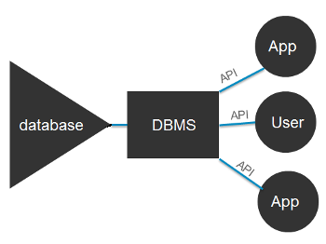

Fig. 2.0: Database Management System

**2.4 Database Management Systems**

A Database is a collection of records. Database management systems are designed as the means of managing all the records. Database Management is a software system that uses a standard method and running queries with some of them designed for the oversight and proper control of databases.

**2.4.1 Types of Database Management Systems:**

There are four structural types of database management systems:

* Hierarchical databases.
* Network databases.
* Relational databases.
* Object-oriented databases

**2.4.1.1 Hierarchical Databases (DBMS):**

In the Hierarchical Database Model we have to learn about the databases. It is very fast and simple. In a hierarchical database, records contain information about there groups of parent/child relationships, just like as  a tree structure. The structure implies that a record can have also a repeating information. In this structure Data follows a series of records, It is a set of field values attached to it. It collects all  records together as a record type. These record types are the equivalent of tables in the relational model, and with the individual records being the equivalent of rows. To create links between these record types, the hierarchical model uses these type Relationships.

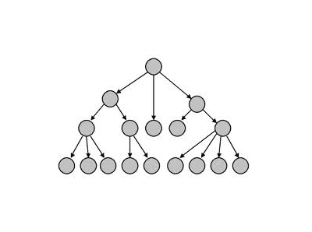

Figure 2.1: Hierarchical Database

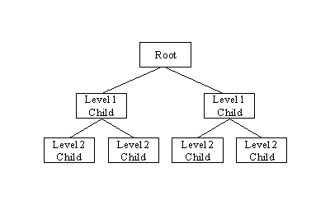

Figure 2.2: Hierarchical Database

**Advantage Hierarchical Databases:**

Hierarchical database can be accessed and updated rapidly because in this model structure is like as a tree and the relationships between records are defined in advance. This feature is a two-edged.

**Disadvantage Hierarchical Databases:**

This type of database structure is that each child in the tree may have only one parent, and relationships or linkages between children are not permitted, even if they make sense from a logical standpoint. Hierarchical databases are so in their design. it can adding a new field or record requires that the entire database be redefined.

**2.4.1.2 Network Database:**

A network databases are mainly used on a large digital computers. It more connections can be made between different types of data, network databases are considered more efficiency It contains limitations must be considered when we have to use this kind of database. It is Similar to the hierarchical databases, network databases. Network databases are similar to hierarchical databases by also having a hierarchical structure. A network database looks more like a cobweb or interconnected network of records.

In network databases, children are called members and parents are called occupier. The difference between each child or member can have more than one parent.

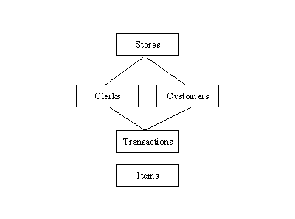

Figure 2.3: Network Database

The Approval of the network data model similar with the esteem of the hierarchical data model. Some data were more naturally modeled with more than one parent per child. The network model authorized the modeling of many-to-many relationships in data.

The network model is very similar to the hierarchical model really. Actually the hierarchical model is a subset of the network model. However, instead of using a single-parent tree hierarchy, the network model uses set theory to provide a tree-like hierarchy with the exception that child tables were allowed to have more than one parent. It supports many-to-many relationships.

**2.4.1.3 Relational Databases:**

In relational databases, the relationship between data files is relational. Hierarchical and network databases require the user to pass a hierarchy in order to access needed data. These databases connect to the data in different files by using common data numbers or a key field. Data in relational databases is stored in different access control tables, each having a key field that mainly identifies each row. In the relational databases are more reliable than either the hierarchical or network database structures. In relational databases, tables or files filled up with data are called relations (tuples) designates a row or record, and columns are referred to as attributes or fields.

Relational databases work on each table has a key field that uniquely indicates each row, and that these key fields can be used to connect one table of data to another.

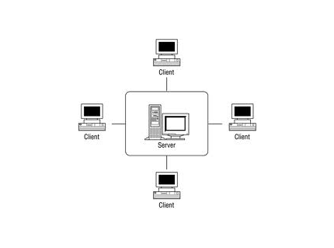

Figure 2.4: Relational Database

**The relational database has two major reasons:**

1. Relational databases can be used with little or no training.
2. Database entries can be modified without specify the entire body.

**Properties of Relational Tables:**

In the relational database we have to follow some properties which are given below.

* It's Values are Atomic
* In Each Row is alone.
* Column Values are of the Same thing.
* Columns is undistinguished.
* Sequence of Rows is Insignificant.
* Each Column has a common Name.

**2.4.1.4 Object-Oriented Model:**

In this Model we have to discuss the functionality of the object oriented Programming .It takes more than  storage of programming language objects. Object DBMS's increase the semantics of the C++ and Java .It provides full-featured database programming capability, while containing native language compatibility. It adds the database functionality to object programming languages. This approach is the analogical of the application and database development into a constant data model and language environment. Applications require less code, use more natural data modeling, and code bases are easier to maintain. Object developers can write complete database applications with a decent amount of additional effort.

The object-oriented database derivation is the integrity of object-oriented programming language systems and consistent systems. The power of the  object-oriented databases comes from the cyclical treatment of both consistent data, as found in databases, and transient data, as found in executing programs.

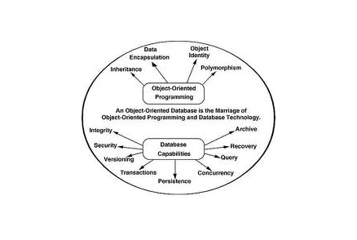  
Object-oriented databases use small, recyclable separated of software called objects. The objects themselves are stored in the object-oriented database. Each object contains of two elements:

Figure 2.5: Object-Oriented Database

1. Piece of data (e.g., sound, video, text, or graphics).
2. Instructions, or software programs called methods, for what to do with the data.

**Disadvantage of Object-oriented databases**

1. Object-oriented databases have these disadvantages.
2. Object-oriented database are more expensive to develop.
3. In the Most organizations are unwilling to abandon and convert from those databases.

They have already invested money in developing and implementing. The benefits to object-oriented databases are compelling. The ability to mix and match reusable objects provides incredible multimedia capability.

**2.4.2 Advantages of a DBMS**

Using a DBMS to store and manage data comes with advantages, but also overhead. One of the biggest advantages of using a DBMS is that it lets end users and application programmers access and use the same data while managing data integrity. Data is better protected and maintained when it can be shared using a DBMS instead of creating new iterations of the same data stored in new files for every new application. The DBMS provides a central store of data that can be accessed by multiple users in a controlled manner. Central storage and management of data within the DBMS provides:

1. Data abstraction and independence
2. Data security
3. A locking mechanism for concurrent access
4. An efficient handler to balance the needs of multiple applications using the same data
5. The ability to swiftly recover from crashes and errors, including restartability and recoverability
6. Robust data integrity capabilities
7. Logging and auditing of activity
8. Simple access using a standard application programming interface (API)
9. Uniform administration procedures for data

Another advantage of a DBMS is that it can be used to impose a logical, structured organization on the data. A DBMS delivers economy of scale for processing large amounts of data because it is optimized for such operations.

**2.5 ICT Applications**

ICT applications, such as e-Government, e-Commerce, e-Education, e-Health and e-Environment, are seen as enablers for development, as they provide an efficient channel to deliver a wide range of basic services in remote and rural areas. ICT applications can facilitate the achievement of millennium development targets, reducing poverty and improving health and environmental conditions in developing countries. Given the right approach, context and implementation processes, investments in ICT applications and tools can result in productivity and quality improvements. In turn, e-applications may liberate technical and human capacity and enable greater access to basic services.​ (Hyderabad, 2010)

**2.5.1 ICT Application in E-Government**

​ There is a growing body of research examining e-Government policies in developing countries that is yielding new insights into the challenges of implementing services through information and communication technologies. e-Government focuses on the adoption of ICTs to deliver government services through the Internet and other emerging digital technologies.

Governments worldwide continue to develop more sophisticated ways to provide the public with online service channels that have evolved from the early days of simple web pages to the recent widespread emergence of online transaction services and integrated service delivery systems. (Hyderabad, 2010)

**2.5.2 ICT Application in E-Health**

The World Health Organization defines e-Health as "…the cost-effective and secure use of information and communications technologies in support of health and health-related fields, including health-care services, health surveillance, health literature, and health education, knowledge and research."

At the International Telecommunication Union, the ICT Applications and Cybersecurity Division provides assistance to developing countri​es, among others, by advising on e-Health strategies and policies, creating guidelines and training materials on e-Health applications, and assisting in implementing technical cooperation projects. Our tools and services are geared to improving access to health services through better use of information and communications technologies (ICTs). (Hyderabad, 2010)

**2.5.3** **ICT Application in E-Environment**

The impact of human activities on the environment – and on climate change in particular – are issues of growing concern confronting life on Earth. Concurrently, information and communication technologies (ICTs) are being rapidly deployed around the world. Although ICTs require energy resources, they also offer opportunities to monitor, learn about and protect the environment, reduce carbon emissions, and mitigate climate change. (Hyderabad, 2010)

**2.6 Senior Citizen**

Old age refers to ages nearing or surpassing the life expectancy of human beings, and is thus the end of the human life cycle. In October 2016, scientists identified the maximum human lifespan at an average age of 115, with an absolute upper limit of 125 years. Terms and euphemisms for old people include, old people (worldwide usage), seniors (American usage), senior citizens (British and American usage), older adults (in the social sciences, the elderly, and elders (in many cultures—including the cultures of aboriginal people). (Zimmer, 2016)

Old people often have limited regenerative abilities and are more susceptible to disease, syndromes, and sickness than younger adults. The organic process of ageing is called senescence, the medical study of the aging process is called gerontology, and the study of diseases that afflict the elderly is called geriatrics. The elderly also face other social issues around retirement, loneliness, and ageism. The chronological age denoted as "old age" varies culturally and historically. Thus, old age is a "social construct" rather than a definite "biological stage".

Old age comprises "the later part of life; the period of life after youth and middle age, usually with reference to deterioration". At what age old age begins cannot be universally defined because it differs according to the context most developed world countries have accepted the chronological age of 65 years as a definition of 'elderly' or older person. The United Nations has agreed that 60+ years may be usually denoted as old age and this is the first attempt at an international definition of old age. However, for its study of old age in Africa, the World Health Organization (WHO) set 50 as the beginning of old age. At the same time, the WHO recognized that the developing world often defines old age, not by years, but by new roles, loss of previous roles, or inability to make active contributions to society.

Most developed Western countries set the age of 60 to 65 for retirement. Being 60–65 years old is usually a requirement for becoming eligible for senior social programs (Barry, 2016). However, various countries and societies consider the onset of old age as anywhere from the mid-40s to the 70s. The definitions of old age continue to change especially as life expectancy in developed countries has risen to beyond 80 years old.

**2.7 Benefits of ICT to Senior Citizens**

Originally, the purpose of old age pensions was to prevent elderly persons from being reduced to beggary, which is still common in some underdeveloped countries, but growing life expectancies and older populations have brought into question the model under which pension systems were designed. By 1990, the United States was spending 30 per cent of its budget on the elderly, compared with 2 per cent on education. The dominant perception of the American old age population changed from “needy” and “worthy” to “powerful” and “greedy,” old people getting more than their share of the nation's resources (Laura, 2003). However, in 2011, using a Supplemental Poverty Measure (SPM), the old age American poverty rate was measured as 15.9%. (James, 2008)

**CHAPTER THREE**

3.0. **RESEARCH METHODOLOGY**

3.1. **Research Approach**

The methods used for the research work is as follows:

1. The design of an ICT Assisted Database for Senior Citizen of Osun State was carried out.
2. The developed ICT Assisted Database for Senior Citizen of Osun State was implemented using Visual Basic .NET and Microsoft Access for the database backend.
3. The developed system was evaluated by comparing the performance of the existing system with the developed system.

**3.2** **The Description of the developed ICT Assisted Database for Senior Citizen of Osun State**

The developed system was designed to be made up of the Splash Screen, Login, Senior Citizen Registration, and Search Forms and are described as follows:-

3.2.1. **The Splash Screen Environment**

This is the environment that display welcome message to the program. This interface is simulated with a progressive bar, which will finally load the program into login page as shown in Figure 3.1.

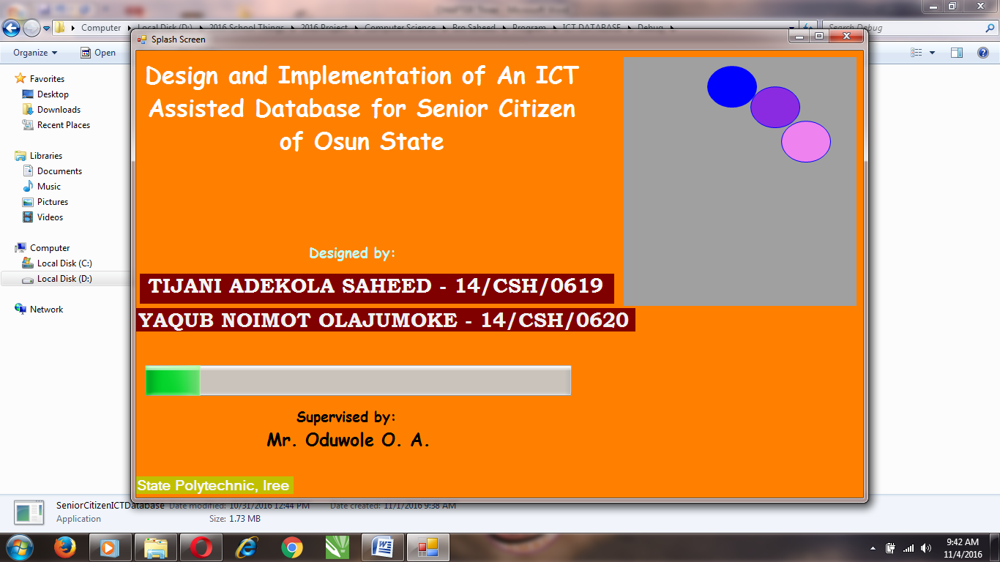

Figure 3.1: Splash Screen Environment of the Developed System

**3.2.2.** **Login Environment**

Login windows pop up immediately the splash screen complete loading. This window serves as security to the application. No unauthorized person will be able to gain access to the software except he is granted access via the username and password of the software as shown in Figure 3.2.

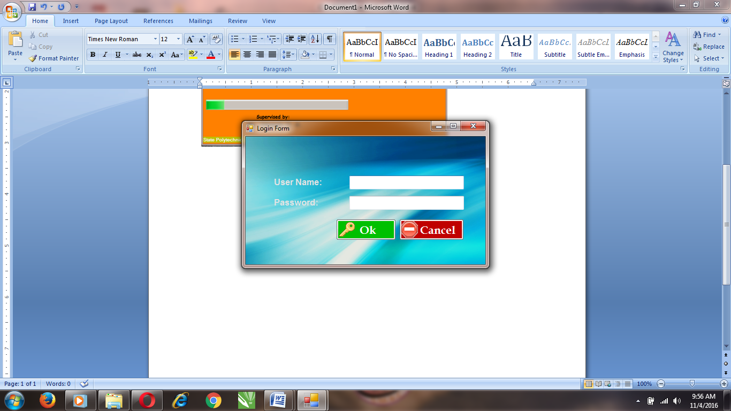

Figure 3.2 Login Environment of the Developed System

**3.2.3. Senior Citizen Registration Page**

This is the environment where both Government and Non Government workers’ registration takes place. The environment consists of Personal details, Biometric Details (face) and Occupational Details as shown in Figure 3.3.

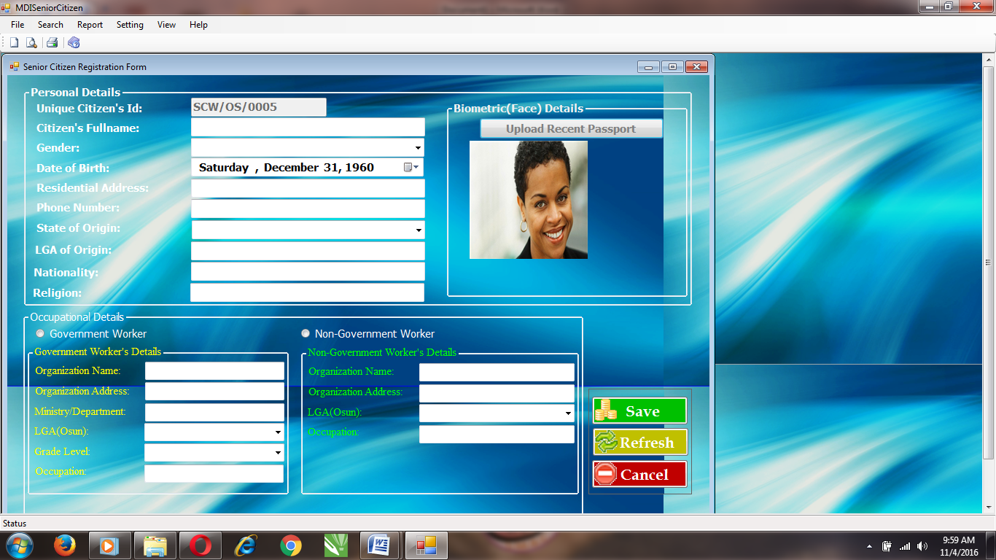

Figure 3.3 Senior Citizen Registration Page of the developed system

**3.2.4. The Search Page**

The Search Page is the environment where the user of the system can search the list of the registered Senior Citizen users in Osun State. The user can wither search with the citizen user ID or Biometric (face) to retrieve the user information as shown in Figure 3.4.

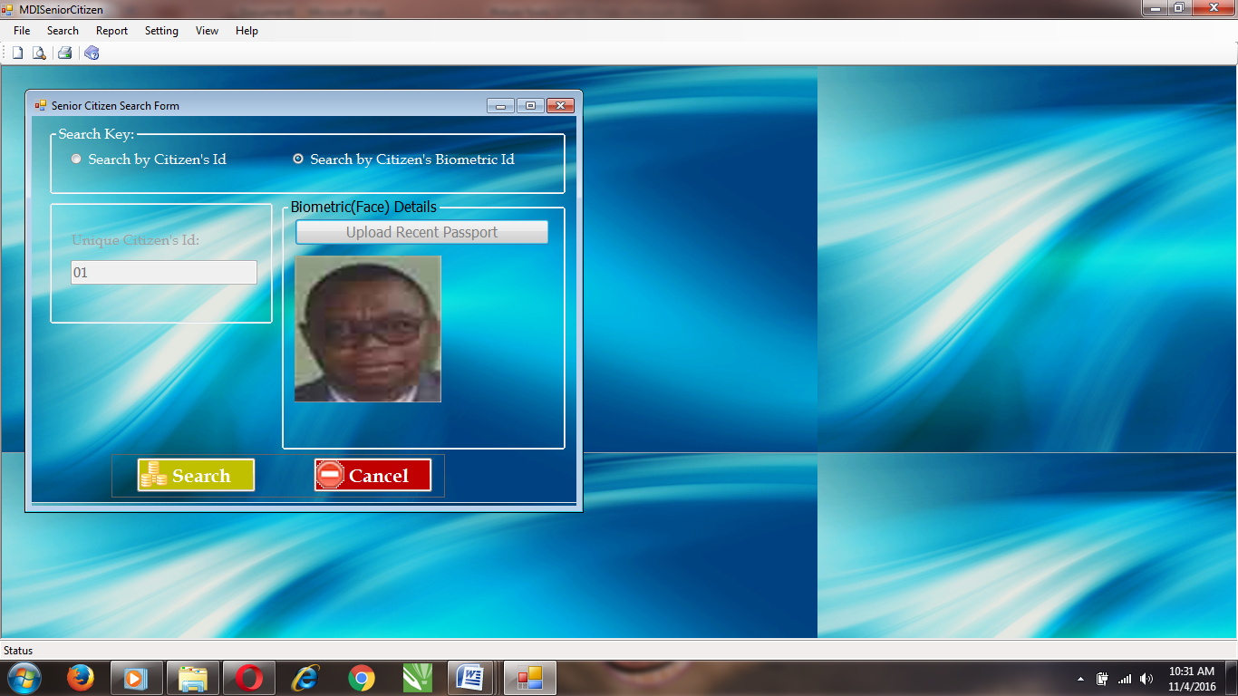

Figure 3.4 Search Page of the design view on developed system.

**3.3. System Implementation**

**Programming Language Used**

The developed system was designed and implemented using Microsoft Visual Basic .NET with Microsoft Access 12 for the database backend. Microsoft Visual Basic .NET is application software used to design application form as well as a websites. Visual Basic .NET is found on Microsoft Visual Studio, a software package that comprised different applications developing software such C#, F#, C++, VB etc. Visual Basic .NET supports many amazing array involving language, this program enables the individual to developed many offline and online applications. Microsoft Access Database was use for storing and retrieving user records and information.

**3.4** **System Evaluation**

**3.4.1. Evaluation Criteria**

The developed system was evaluated based on the following criteria:

* 1. Usability
  2. Speed

**3.4.2. Evaluation Methodology**

The developed system was evaluated by administering questionnaires on 50 users. The completely filled copies of the questionnaires were collected and used for the analysis of the result.

**CHAPTER FOUR**

**4.0.** **RESULTS AND DISCUSSION**

**4.1. Results**

The result of the evaluation of the developed system is as presented in table 4.1, and 4.2 and figures 4.1, and 4.2

**Table 4.1.** The table of responses from users on usability of the system.

|  |  |  |
| --- | --- | --- |
| **The developed system is easy to use** | **Frequency (users)** | **Percentage** |
| Strongly Agree | 38 | 76% |
| Agree | 11 | 22% |
| Disagree | 1 | 2% |
| Strongly Disagree | 0 | 0% |
| Total | 50 | 100 |

Figure.4.1 Graphical Representation of the responses of the users on usability

**Table 4.2.** The table of responses from the users on the speed of the system

|  |  |  |
| --- | --- | --- |
| **The developed system is fast** | **Frequency (users)** | **Percentage** |
| Strongly Agree | 41 | 82% |
| Agreed | 7 | 14% |
| Disagreed | 2 | 4% |
| Strongly Disagree | 0 | 0% |
| Total | 50 | 100 |

Figure 4.2: Graphical Representation of the responses of the users on speed

**4.2. Discussion**

Table 4.1 and figure 4.1 shows that 49 out of 50 users agreed and only 1 user disagreed that the system is easy to use. Also table 4.2 and figure 4.2 shows that 48 out of 50 users agreed that the system is fast and accurate. From the result shown in the table, it is concluded that majority of users agreed that the system is usable and fast in operation.

**CHAPTER FIVE**

**5.0.** **CONCLUSION AND RECOMMENDATION**

**5.1.** **Conclusion**

In this project work, An ICT Assisted Database for Senior Citizen of Osun State was designed and implemented using Microsoft Visual Basic .NET programming language and Microsoft Access was use as the database backend. The developed system was evaluated based on usability and speed of the system.

It is concluded from the result of the implementation, that the developed system is usable, easily accessible and it provide a secured database system for Senior Citizen in Osun State has been developed.

**5.2.** **Recommendation**

It is recommended that:

1. The developed system should be used for keeping records and information of Senior Citizen in the Osun State, in order to gather all relevant information of the Old People in the State.
2. The developed system can also be design and place on network which all the senior citizen will be able to access without visited a particular zone.

**REFERENCES**

Barry, Patricia. (2016)"Medicare Eligibility Requirements - How to Qualify for Medicare –

AARP Every...". AARP.

Bachman, (1973), "PTCA in the elderly: The "young-old" versus the "old-old"". Journal of the

American Geriatrics Society. 40 (1): 19–22.

Chaffin A. J., Harlow S. D. (2005) Cognitive learning applied to older adult learners and

technology. Educational Gerontology. 2005;31(4):301–329.

Chapple, (2005) Use of the computer and the internet by well older adults. Activities,

Adaptation & Aging. 2013;37(1):63–68. doi: 10.1080/01924788.2012.729186.

Hawthorn D. (2000) Possible implications of aging for interface designers. Interacting with

Computers. 2000;12(5):507–528. doi: 10.1016/S0953-5438(99)00021-1.

Heying Jenny, Z., Xiaotian, F., &Baozhen, L. (2008). Placing Elderly Parents in Institutions in

Urban China: A Reinterpretation of Filial Piety. Research On Aging, 30(5), 543-571.

Hyderabad and Pat Thane, (2010), Old Age from Antiquity to Post-Modernity (Routledge)

Kumada, (2009) Aging, The Individual & Society (Cengage, 10th edition, 2014), 6-7.

Lalitha, (2004) History of Old Age: From Antiquity to the Renaissance, trans. Sarah Hanbury

Tenison (University of Chicago Press, 1989) Minois, 303.

Laura Katz Olson, (2003) The Not-so-golden Years: Caregiving, the Frail Elderly, and the Long-

term Care Establishment (Rowman and Littlefield, 2003), 4.

Margaret Rouse (2005) “Database Definition”

McConatha D. (2002) Aging online: toward a theory of e-quality. In: Morrell R. W., editor.

Older Adults, Health Information, and the World Wide Web. Mahwah, NJ, USA: Lawrence Erlbaum Associates; 2002. pp. 21–41.

Melenhorst A.-S., Rogers W. A., Bouwhuis D. G. (2006) Older adults' motivated choice for

technological innovation: evidence for benefit-driven selectivity. Psychology and Aging.

2006;21(1):190–195. doi: 10.1037/0882-7974.21.1.190. [PubMed]

Murray A., Gregor P. (2011) Computer use has no demonstrated impact on the well-being of

older adults. International Journal of Human Computer Studies. 2006;64(8):744–753. doi:

10.1016/j.ijhcs.2006.03.001.

Patsoule E., Koutsabasis P. (2014) Redesigning websites for older adults: a case study.

Behaviour & Information Technology. 2014;33(6):561–573. doi: 10 .1080/0144929x.2013.810777.

James S., Guijarro J.-M., Blat J. (2012) Selective attention in web forms: an exploratory case

study with older people. Behaviour and Information Technology. 2012;31(2):171–184. doi: 10.1080/01449291003767920.

Slegers K., van Boxtel M. P. J., Jolles J. (2012) Computer use in older adults: determinants and

the relationship with cognitive change over a 6 year episode. Computers in Human

Behavior. 2012;28(1):1–10. doi: 10.1016/j.chb.2011.08.003.

Tatnall A. (2014) ICT, education and older people in Australia: a socio-technical analysis.

Education and Information Technologies. 2014;19(3):549–564. doi: 10.1007/s10639-

013-9300-x.

Wagner N., Hassanein K., Head M.(2010) Computer use by older adults: a multi-disciplinary

review. Computers in Human Behavior. 2010;26(5):870–882. doi: 10.1016/j.chb.2010.03.029.

Wandke H., Sengpiel M., Sönksen M. (2012) Myths about older people's use of information and

communication technology. Gerontology. 2012;58(6):564–570. doi: 10.1159/000339104.

Zimmer, Carl (2016). "What's the Longest Humans Can Live? 115 Years, New Study

Says". New York Times. Retrieved October 6, 2016.

**Flow Chart**

Start

Display Splash Screen

Display Login Page

Read username & Password

Is username & password correct?

Perform New Citizen Registration

Yes

No

Read Citizen Personal Detail & Occupation

Perform Search citizen info.

Save entries to DB

Is ID validated?

Yes

No

Read citizen ID/Biometric ID

Display the Senior citizen info

View Registered Citizen Report

View Govt. Workers Report

View Non-Govt. workers report

Stop